Toyhouse@SUTD-IDC

**1. Introduction**

The curriculum provided by SUTD-IDC creates a wide range of choice for students from all disciplines, where cross-domain knowledge is available for everyone.

Toyhouse creates a learning ecology for students from different areas of study to meet together, generate ideas, and conduct research. XLP as a method to design learning process for students, creates a transdisciplinary learning environment in which students work as groups to experience a complete life cycle of product, system, or service design. From these short-term learning activities, they obtain the facility to identifying and navigating sophisticated problems by utilizing all available resources, they construct the awareness of collaborative learning, and start making long-term plans for their career.

Collaboration of Toyhouse and SUTD-IDC will provide a more encouraging learning environment to support design research.

Specifically, these goals can be achieved by:

1. Co-design learning activities at THU and SUTD-IDC.
2. Introducing a complete process of design methodology.
3. Exchange students between Toyhouse and SUTD.
4. Cooperation on Engineering Education Research.

**2. Co-design Learning Activities (XLP) at Tsinghua University and SUTD-IDC**

2.1 Course Content Design

With its flexibility, XLP can incorporate a variety of different content. It will be a good introduction to the IDC projects that students will involve in the future.

A proper story should be applied to the development. According to the most demanding needs, building a sustainable living environment is the challenge all countries face together, especially in the developing world. According to the research at SUTD-IDC, the following aspects of research should be designed as elements in the learning activities:

1. Building Sustainable Architecture

As one of the major research areas at SUTD-IDC, designing and prototyping sustainable architecture is essential. In the course-design process, challengers will extract key ideas in architecture design and put them into the assignments to challenge other students.

1. Product and System Design

Engineering products are essential to create the building blocks of the sustainable environment. In this part, the challenge designers will involve themselves in the research projects at SUTD-IDC, and design components of the challenge based on what they learned from the research project, together with researchers.

1. Information Systems

All participants should be able to use IT technology Connect all virtual and physical components. Challengers will prepare for modules to help students easily get access to services on the web, open-source tools, and computation facilities such as Mathematica and Modeling tools.

2.2. Organizing an XLP Workshop

A learning activity can be efficiently designed by following a standard workflow. XLP uses a dual-stage design model, in which students design challenges for themselves. The Challengers prepare for the content, assignments and tasks prior to the course, the Missionaries take the challenge from the Challengers. In addition, course stuff provides guidelines, supportive resources to enable the process. This process can be illustrated by the following graph:

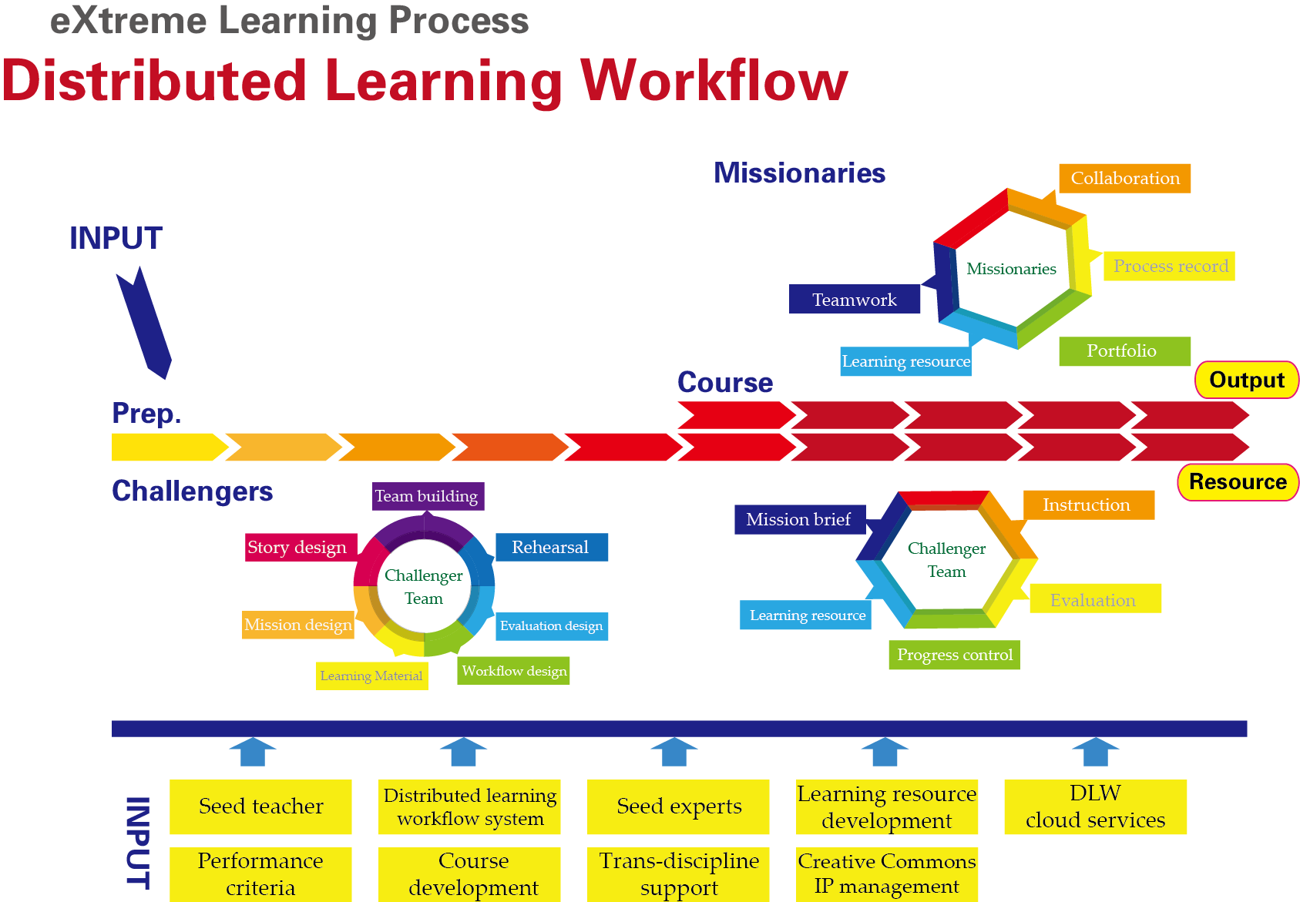

**4. Exchange students between Toyhouse and SUTD-IDC**

Students from both universities can visit and work at the other. Tsinghua students can help SUTD-IDC design and organize learning activities, and bring workforce to research groups at SUTD-IDC. SUTD-IDC students will bring powerful design thinking to THU.

**5. Engineering Education Research**

5.1 Learning Activity Workflow Design

For professional and scalable learning activity design, more structural and detailed design is required, specifically, the architectural design, process design and workflow specification.

(Zhang Hong Yan’s designs)

5.2 Knowledge Management

The core is content of knowledge. One focus of the research is to manage content of various formats, and help student use and reuse outcome from others.

5.3 Evaluation System Establishment

Evaluation system usually determines students’ behavior and performance. Research on this has two aspects:

First, how to effectively increase the quality and efficiency of learning process?

(Process management such as Dynamic Project Control)

Second, how to design the evaluation system so that the potential of students can be best enabled?

(Value System Construction)

5.4 Infrastructure Management

Transdisciplinary learning environment requires a set of infrastructure that enables communication, collaboration, and all other needs above for physical and online learning. For example, social network based online learning platform, modules for future development, learning space and so on.